NAME____________________________LAB MEETING DAY/TIME______________

Lab 5 Fossils

For the first part of Lab 5, you will be identifying a set of fossils. These are placed around the lab room, and you need to identify 10 fossils. You should use Exercise 8 pre-reading materials AND pages 174-188 of Exercise 12 when working on your identifications.

# **Fossil Samples**

You are provided samples of fossils around the lab classroom; choose 10 of these to identify Examine each sample carefully, make a rough sketch of the fossil, record its distinguishing characteristics, and then decide on a fossilization mode, name, and likely phylum of the fossil. NOTE: these fossils are all from Kingdom Animalia.

|  |  |  |  |  |
| --- | --- | --- | --- | --- |
| **#** | **Sketch and Description** | **Fossilization Mode** | **Name** | **Phylum** |
|  |  |  |  |  |
|  |  |  |  |  |
|  |  |  |  |  |
|  |  |  |  |  |
|  |  |  |  |  |
|  |  |  |  |  |
|  |  |  |  |  |
|  |  |  |  |  |
|  |  |  |  |  |
|  |  |  |  |  |

# Go on to the next page of this worksheet to continue Lab 5

Lab 5, Index fossils

For the second part of Lab 5, we will work through parts of Exercise 12, where you will be examining a suite of fossils (pictures) from a hypothetical field area. Your goal is to determine the geologic age of each rock group, based on the fossils present. We will skip the sections on depositional sequence, for now.

# **Exercise 12, Part A**

***This is a cross-sectional drawing of your hypothetical study area. The colors represent different rock formations and the numbers pointing to each represent the groups of fauna found on pages 189-196 of the lab manual. You will come back to this drawing after completing later parts of the exercise.***

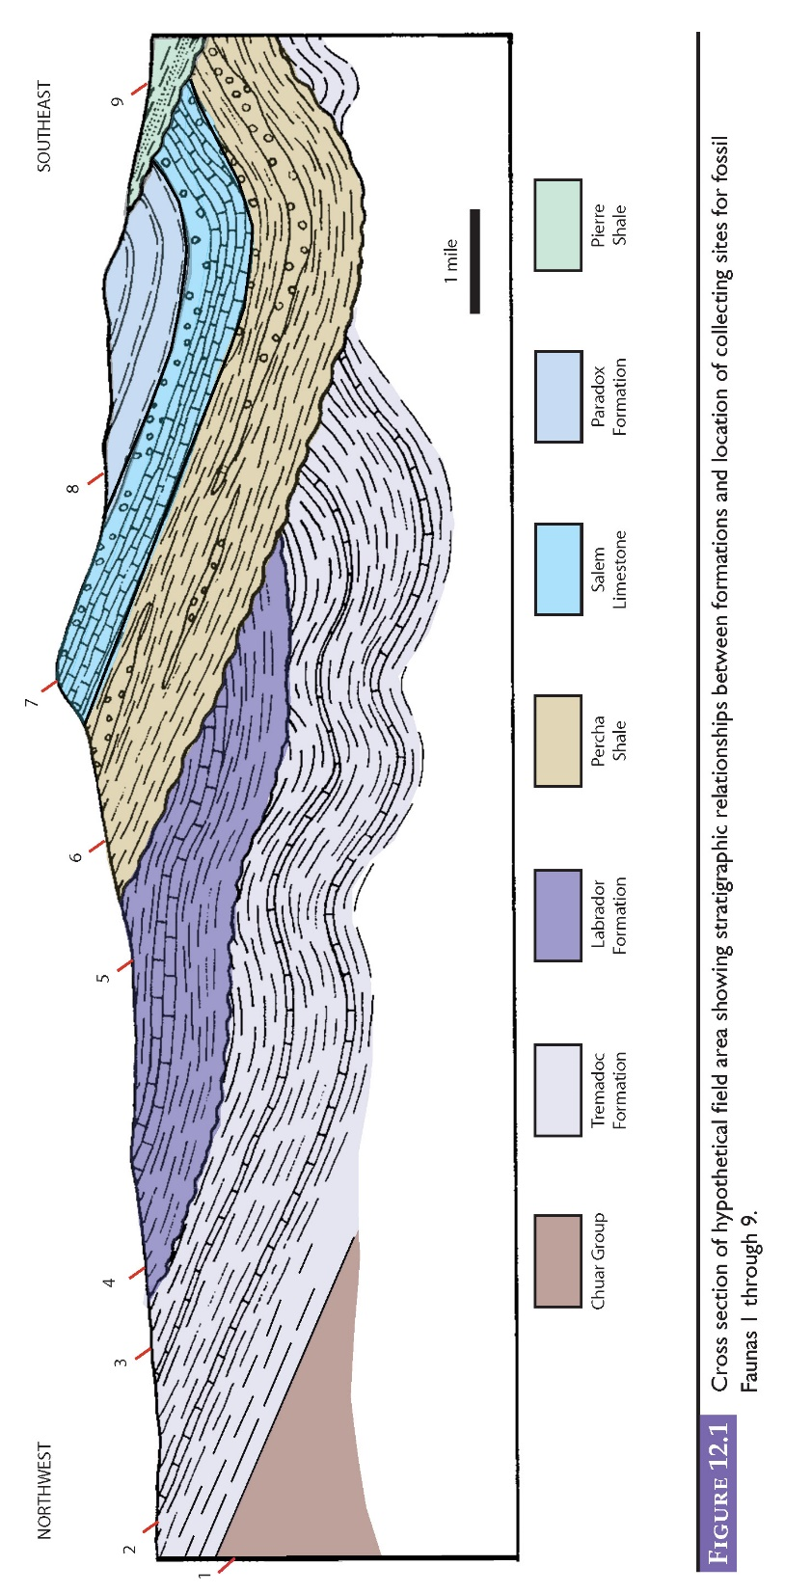

***Using the drawings and information on fossils on pages 174-188 of your lab manual, identify the fossils of each of the fauna groups on pages 189-196 and their ages. Fill out the tables by***

1. ***listing the taxa of the fossils on the right side of the figure***
2. ***shading in the age range of each fossil on the left side of the figure***
3. ***recording the age of the formation by choosing the geologic time period in common with all the fossils***

***Your goal is to use the index fossils to find an age range for each rock group in the cross section above.***

**FAUNA 1 (pg 189)**

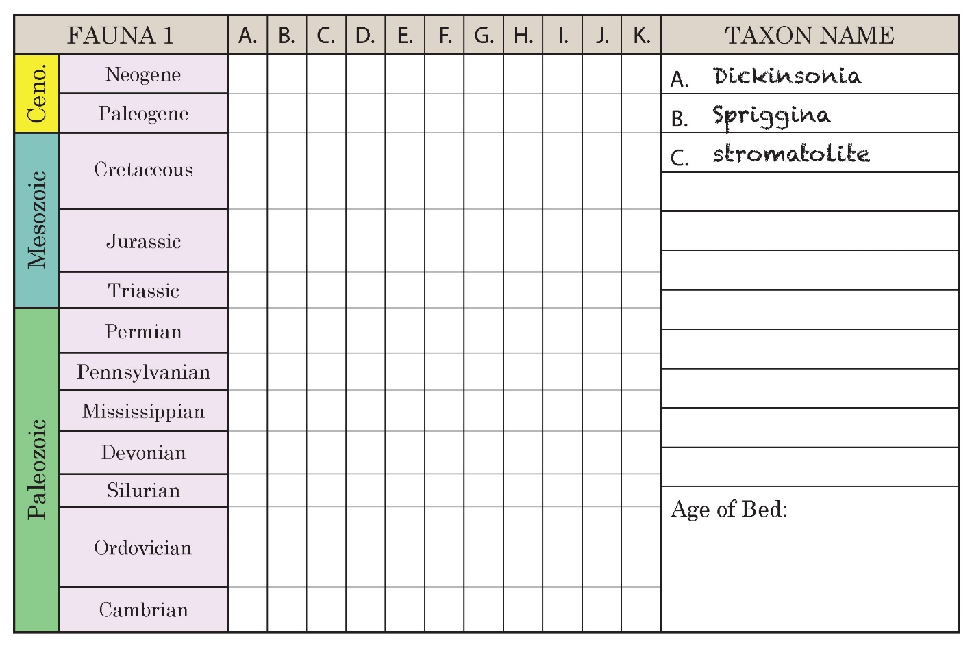

**FAUNA 2 (pg 190)**

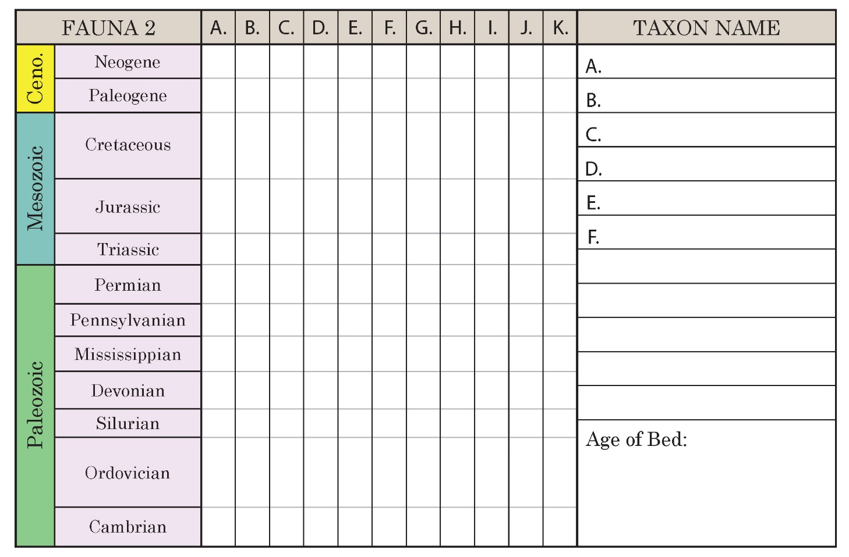

**FAUNA 3 (pg 191)**

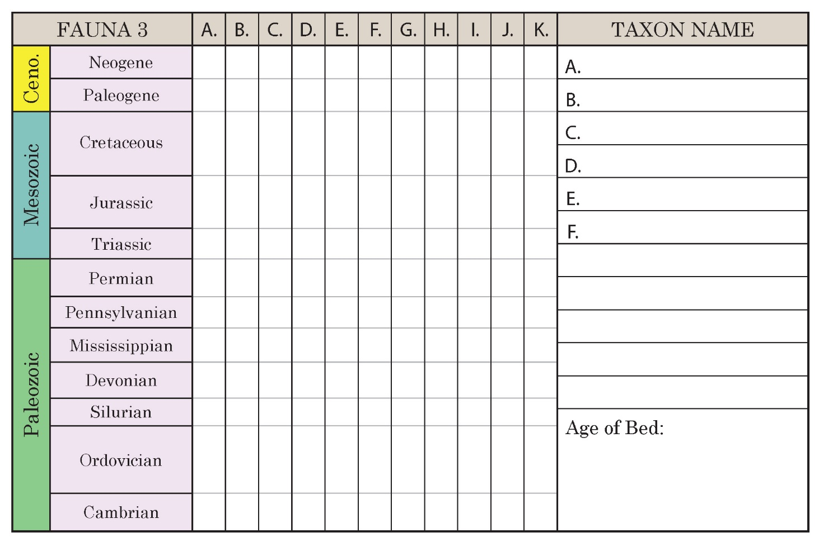

**FAUNA 4 (pg 192)**

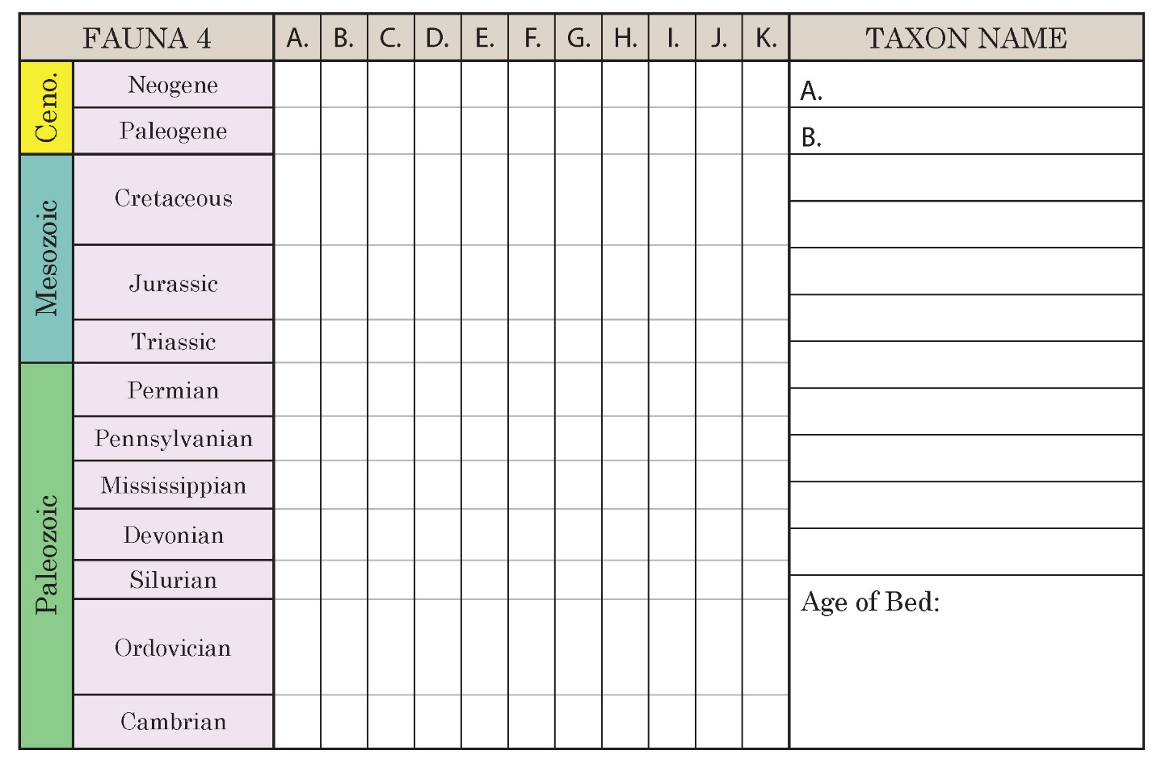

**FAUNA 5 (pg 192)**

**FAUNA 6 (pg 193)**

**FAUNA 7 (pg 194)**

**FAUNA 8 (pg 195)**

**FAUNA 9 (pg 196)**

# **Exercise 12, PART B**

**Once you have determined the ages of each fauna, write these on the cross section above the appropriate group, and below the name of each group in the legend.**

# **Exercise 12, PART C, D, E, and F**

**You may skip these exercises. We may come back to these once we learn more about depositional sequences in future coursework.**

# **Lab 5 Reflection**

**Of the fossils we looked at today, what was the most interesting?**

**Explain how fossils can help with determining the age, sequence of events, and environmental history of an area…use a specific fossil as an example.**